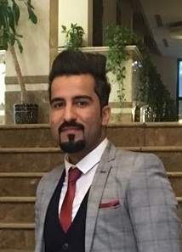

**WORK EXPERINCE**

**May 2017- Iraq duty free**

* CUSTOMER CARE
* Maintaining accurate records of cash reports to be sent to Accounting department.
* Evaluating the customer care and sales team performance to enhance the overall performance.
* Ensuring that all customer care and sales staff is professionally trained to answer any question.
* Recruiting, training and mentoring new sales associates. Follow-up inventory and ensure product availability.

**Jun 2015 -Feb 2017 Motorola-Systel telecom**

* STORE KEEPER
* Interviewed job candidates and made staffing decisions.
* Maintain store set up and daily operations through schedule optimization and delegation.
* Managing all resources within the store to provide customers with a leading shopping experience.
* Managing stock levels and decision making related to inventory management.
* Reported to the district manager regarding all store and staff issues.
* Building and maintaining relationships with customers.
* Checking the availability and visibility of products.
* Items were antenna, LCD screen, pipe fitting, cables

Languages

* Arabic-native
* English-fluent
* Germany-beginner

**PERSONAL SKILL**

* Solving complex problems
* Creative thinking
* Friendly
* Accuracy
* Analytics
* Clever
* Dependability
* Educated
* Fast learning
* Focused
* Honesty
* Organized
* Supervising
* Team-working
* Trustworthy

Ibrahim Hmmood Hamzah

Chemical\Biochemical Engineer

PROFILE

Experienced Store Manager with a demonstrated history of working in the computer networking industry. Skilled in Customer Service, Account Management, Sales, Inventory Management, and Sales Process. Strong sales professional with a Bachelor's degree focused in Biochemical Engineering from University of Baghdad 2014.

CONTACT ME

**Phone number:** 009647707929454

**Email:** [ibrahmood10@yahoo.com](mailto:ibrahmood10@yahoo.com)

SKILLS

1. Microsoft Office Applications/Professionally
2. Photos/Videos/Audio Editing and designing programs\Medium
3. Admin on social media (Facebook, instagram….)